Python setup:
Installing pymango:
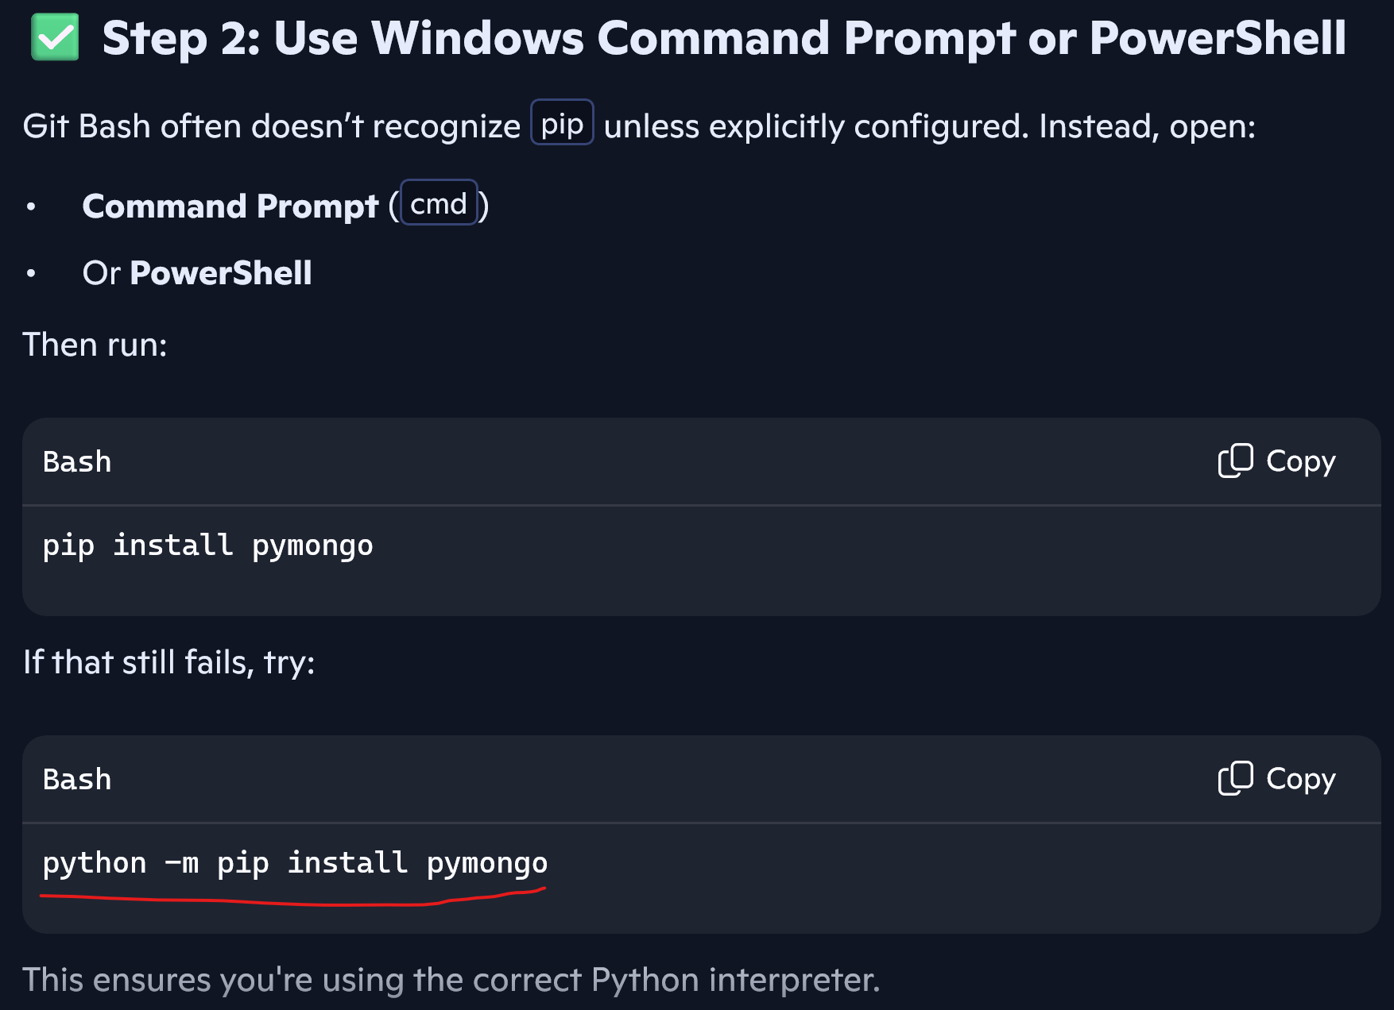
Worked:
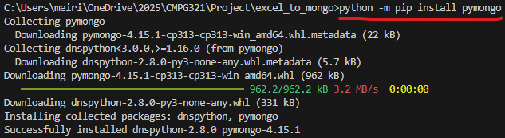
Verify Installation:

Installing pandas:
pip install pandas
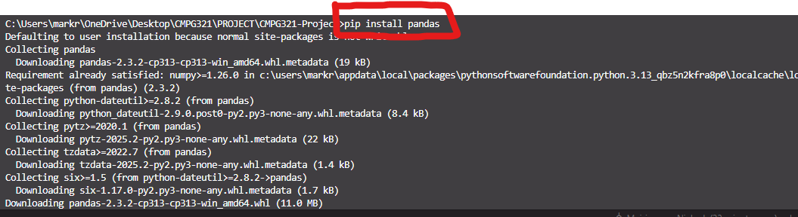
Installing pip openpyxl:
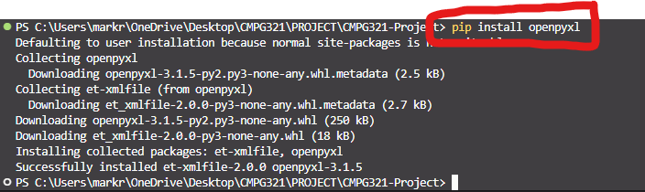
pip install openpyxl

Ensure MongoDB connection:
